On containers.do1.exam

Gitea:

Configure server domain and gitea base url to 192.168.99.202 / 192.168.99.202:3000

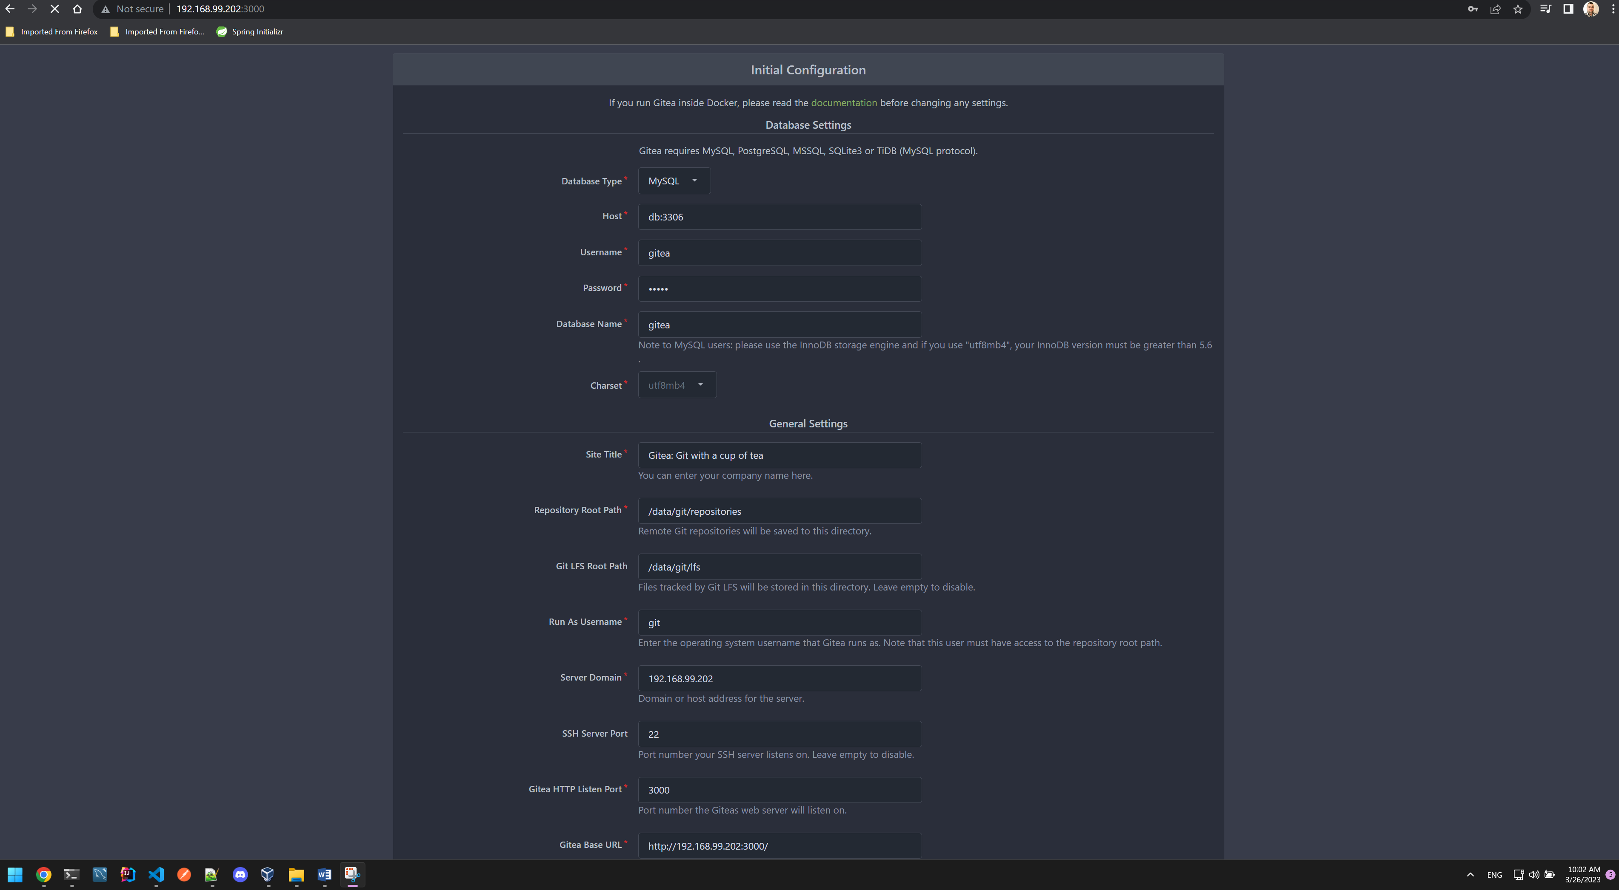

Register account and migrate repository from github:

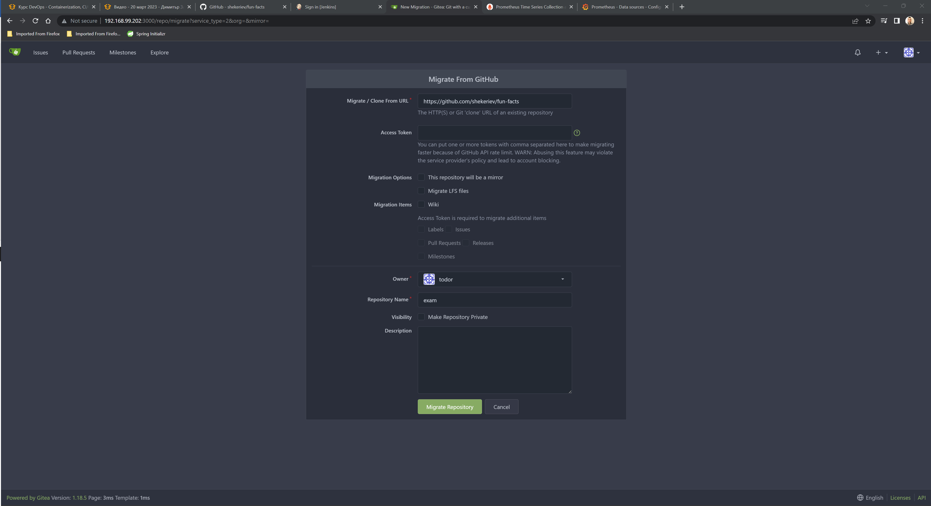

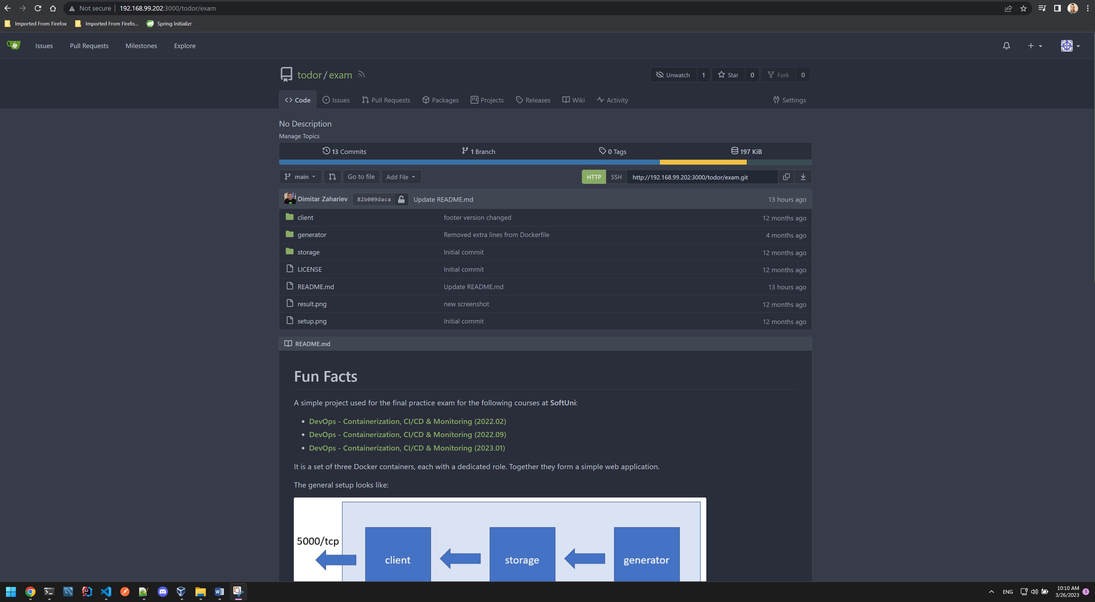

On pipelines.do1.exam

Jenkins:

Install suggested plugins:

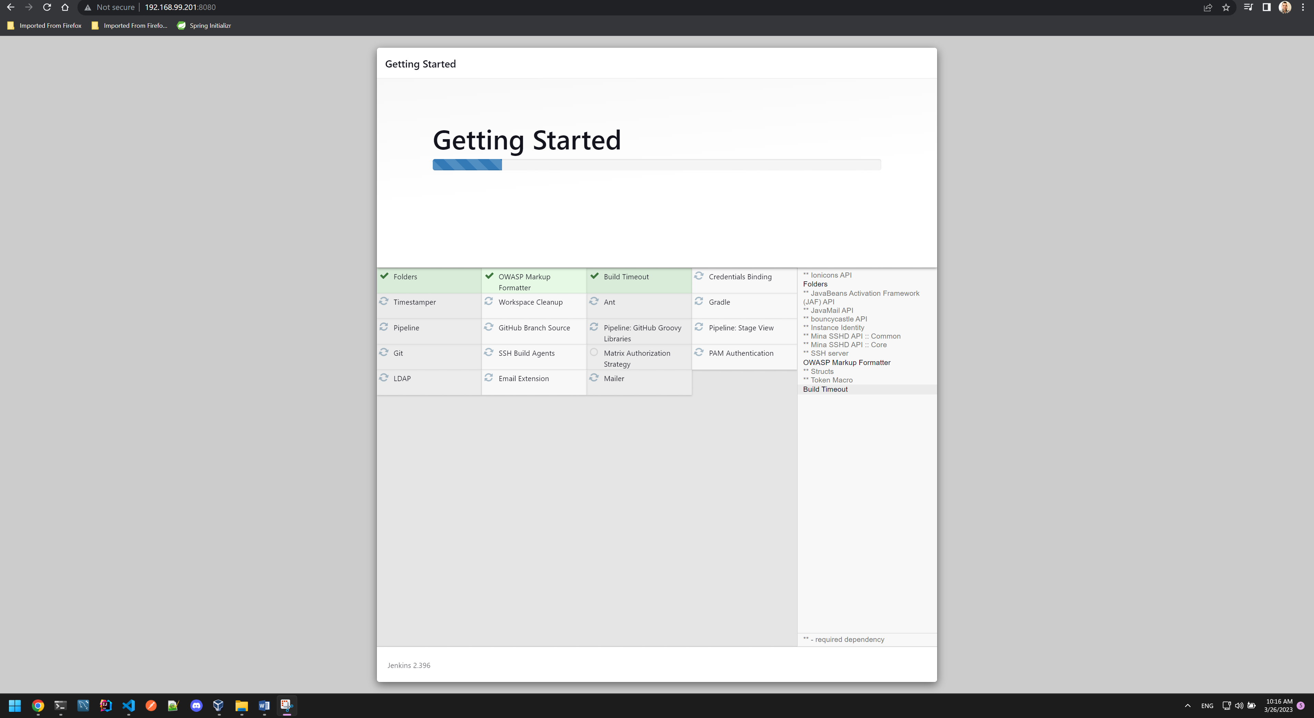

Configure admin user – admin/admin. Confirm default URL configuration- http://192.168.99.201:8080/

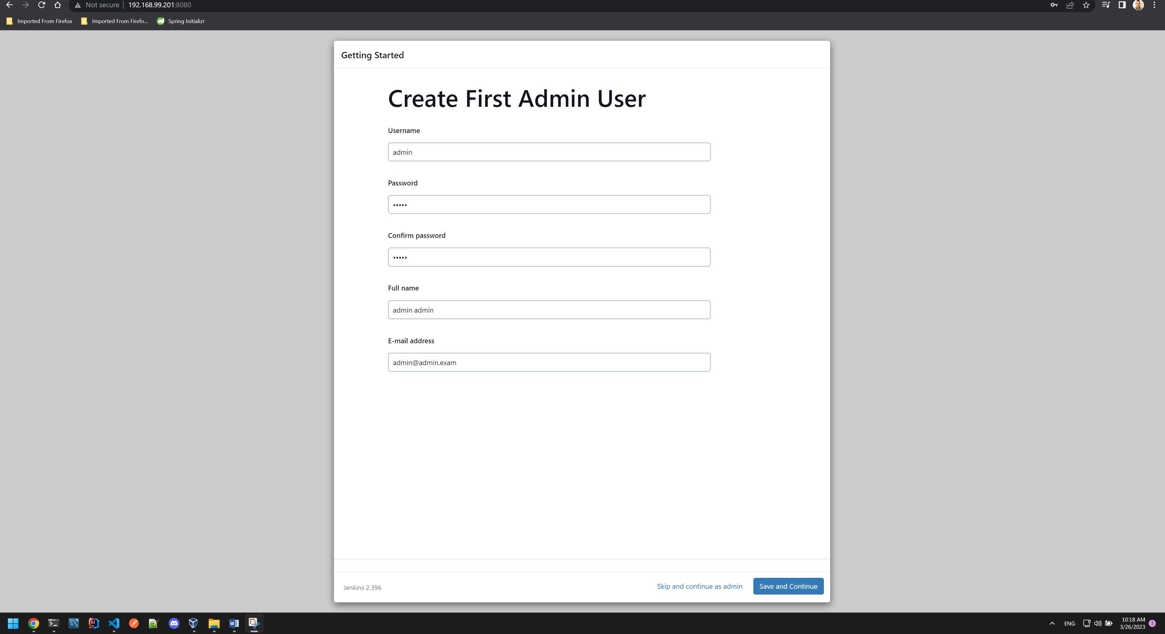

Install gitea and ssh plugins:

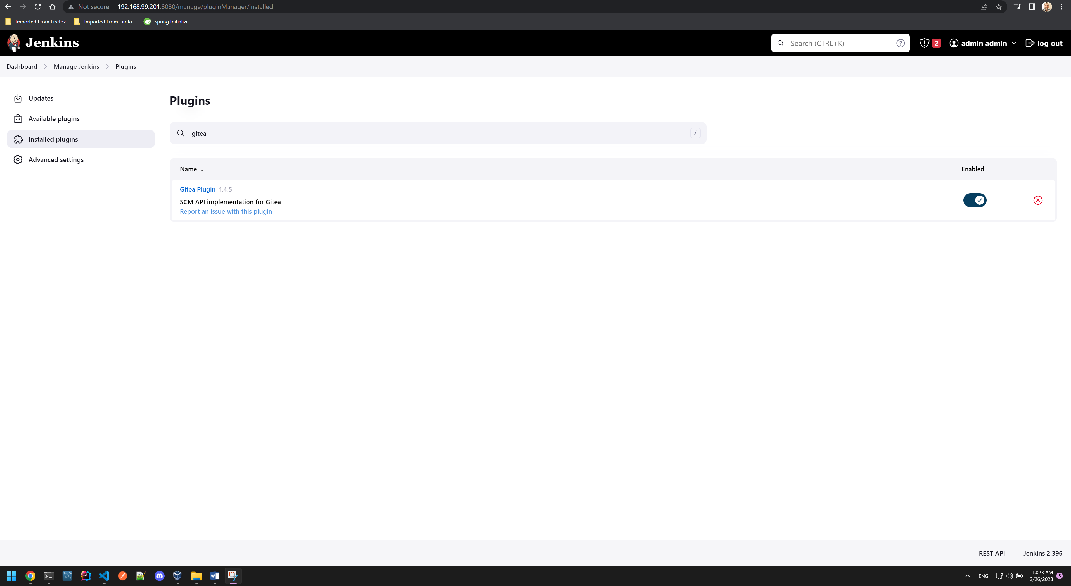

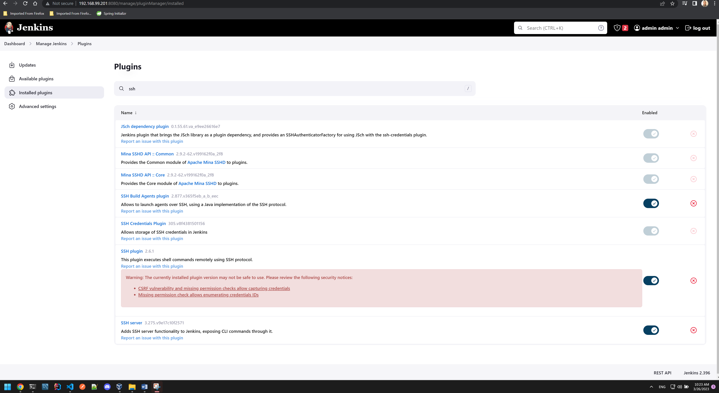

Create vagrant user credentials. Generate access token from dockerhub for the user and create docker credentials on Jenkins with username from dockerhub and the access token

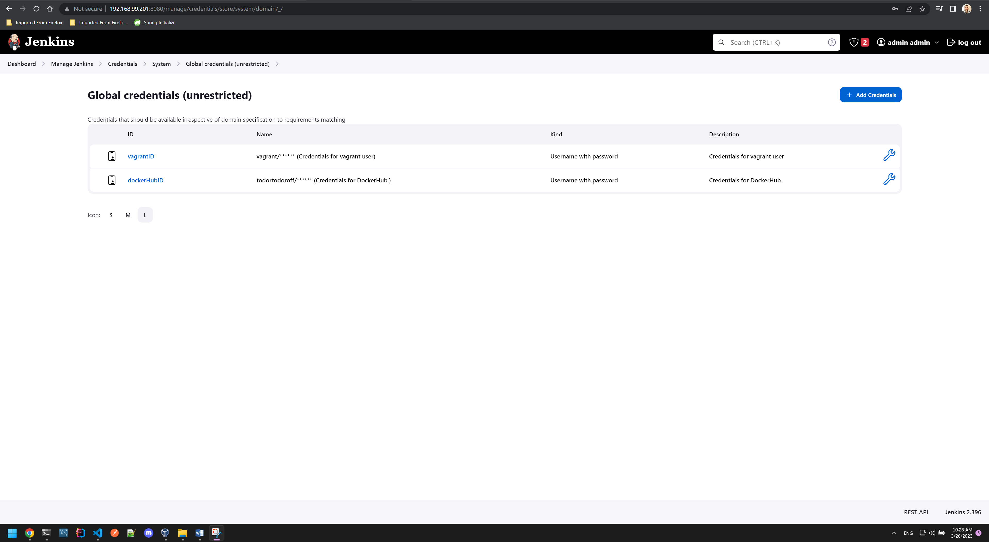

Set a ssh remote host for the slave connection

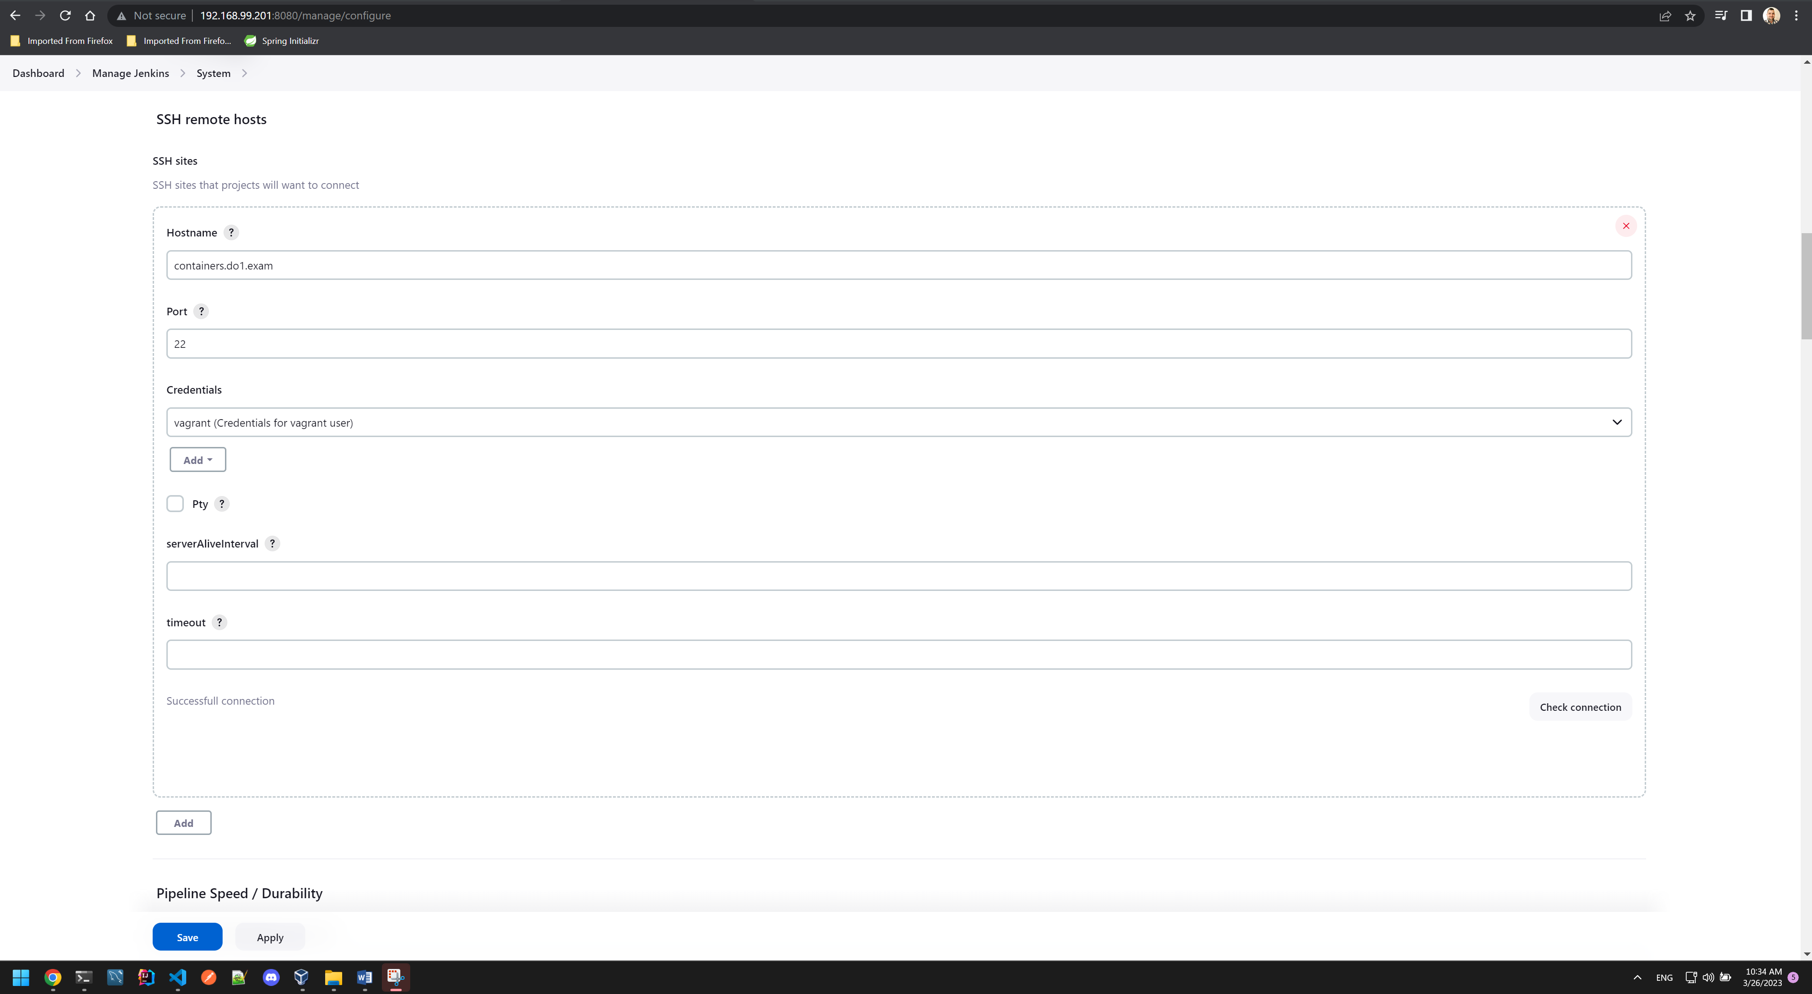

Establish an ssh connection from pipelines.do1.exam with Jenkins user to vagrant user on containers.do1.exam to pass the fingerprint

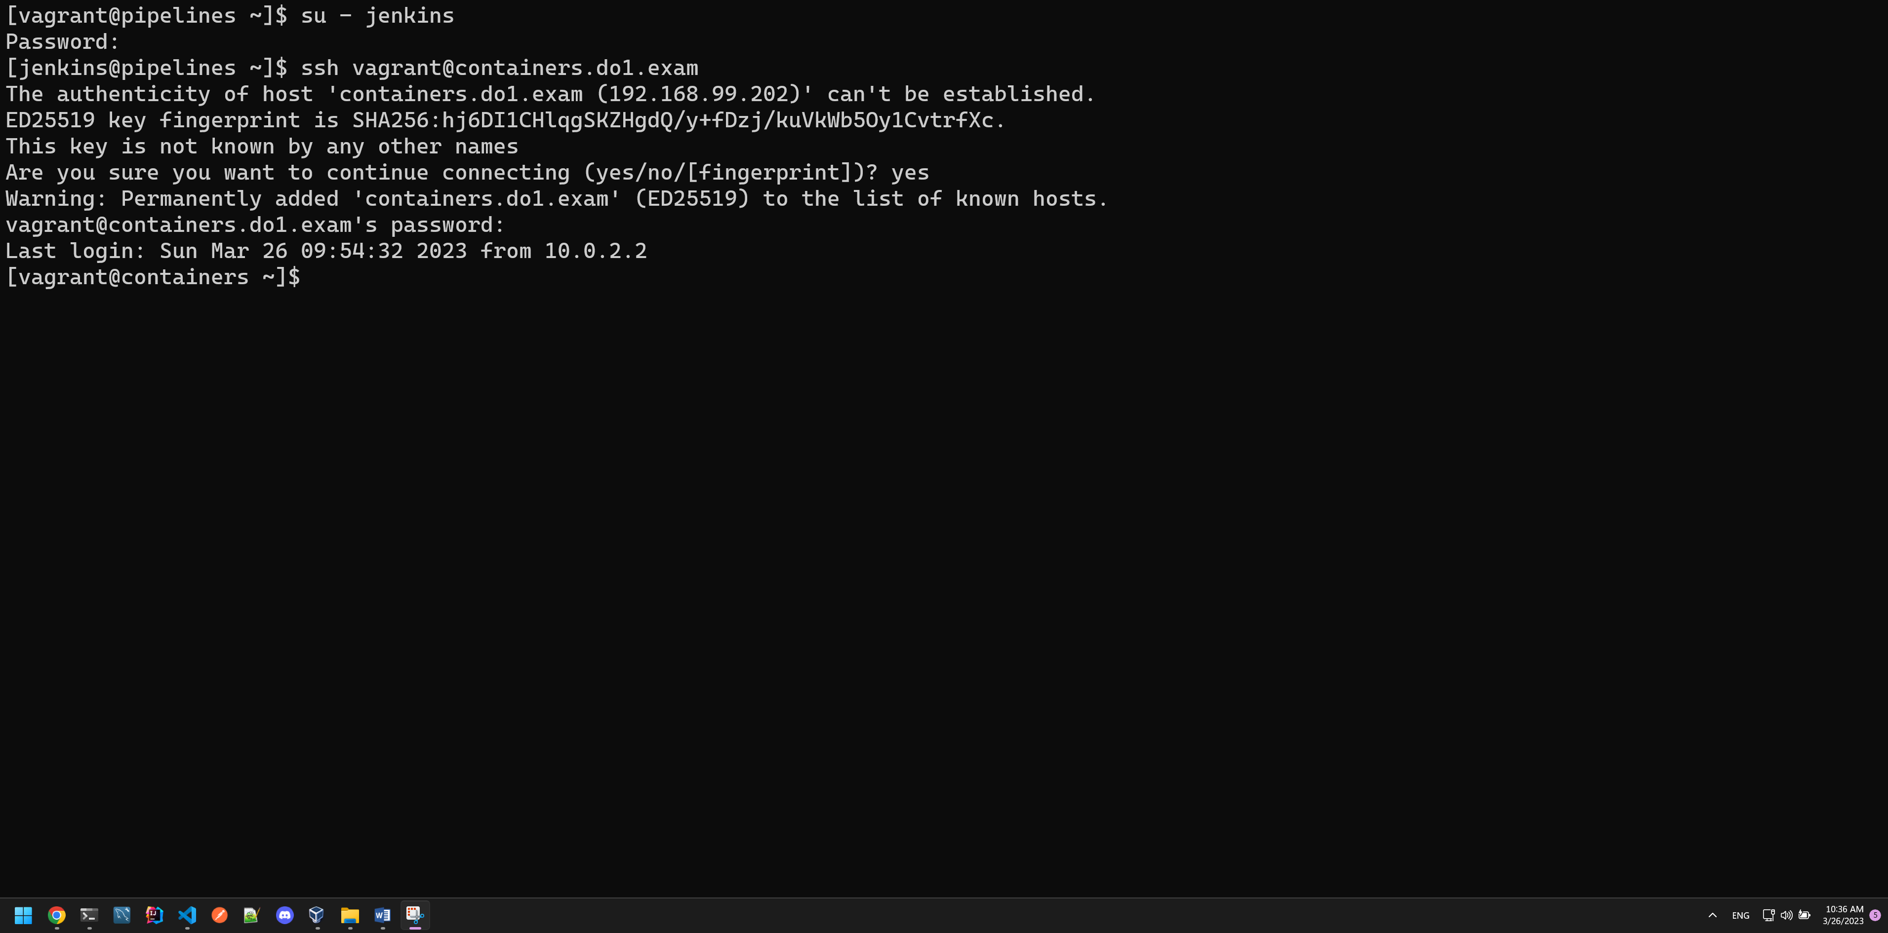

Create slave agent:

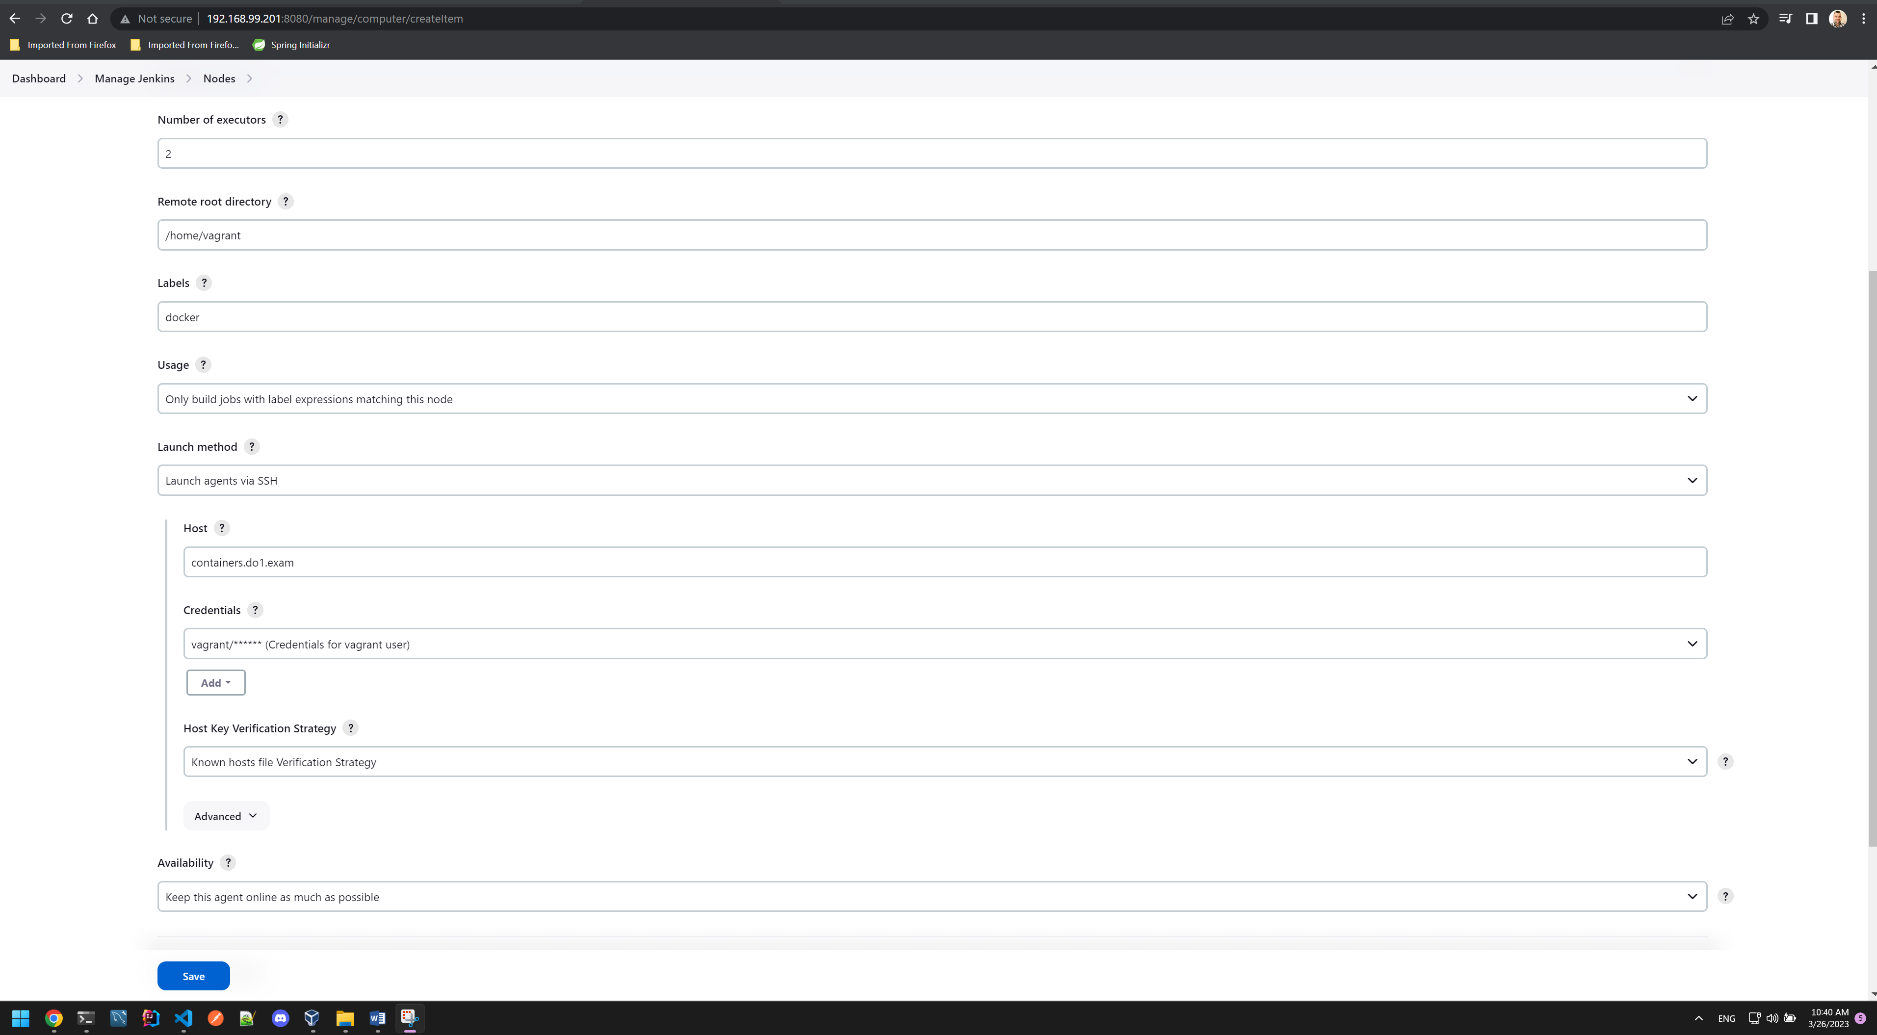

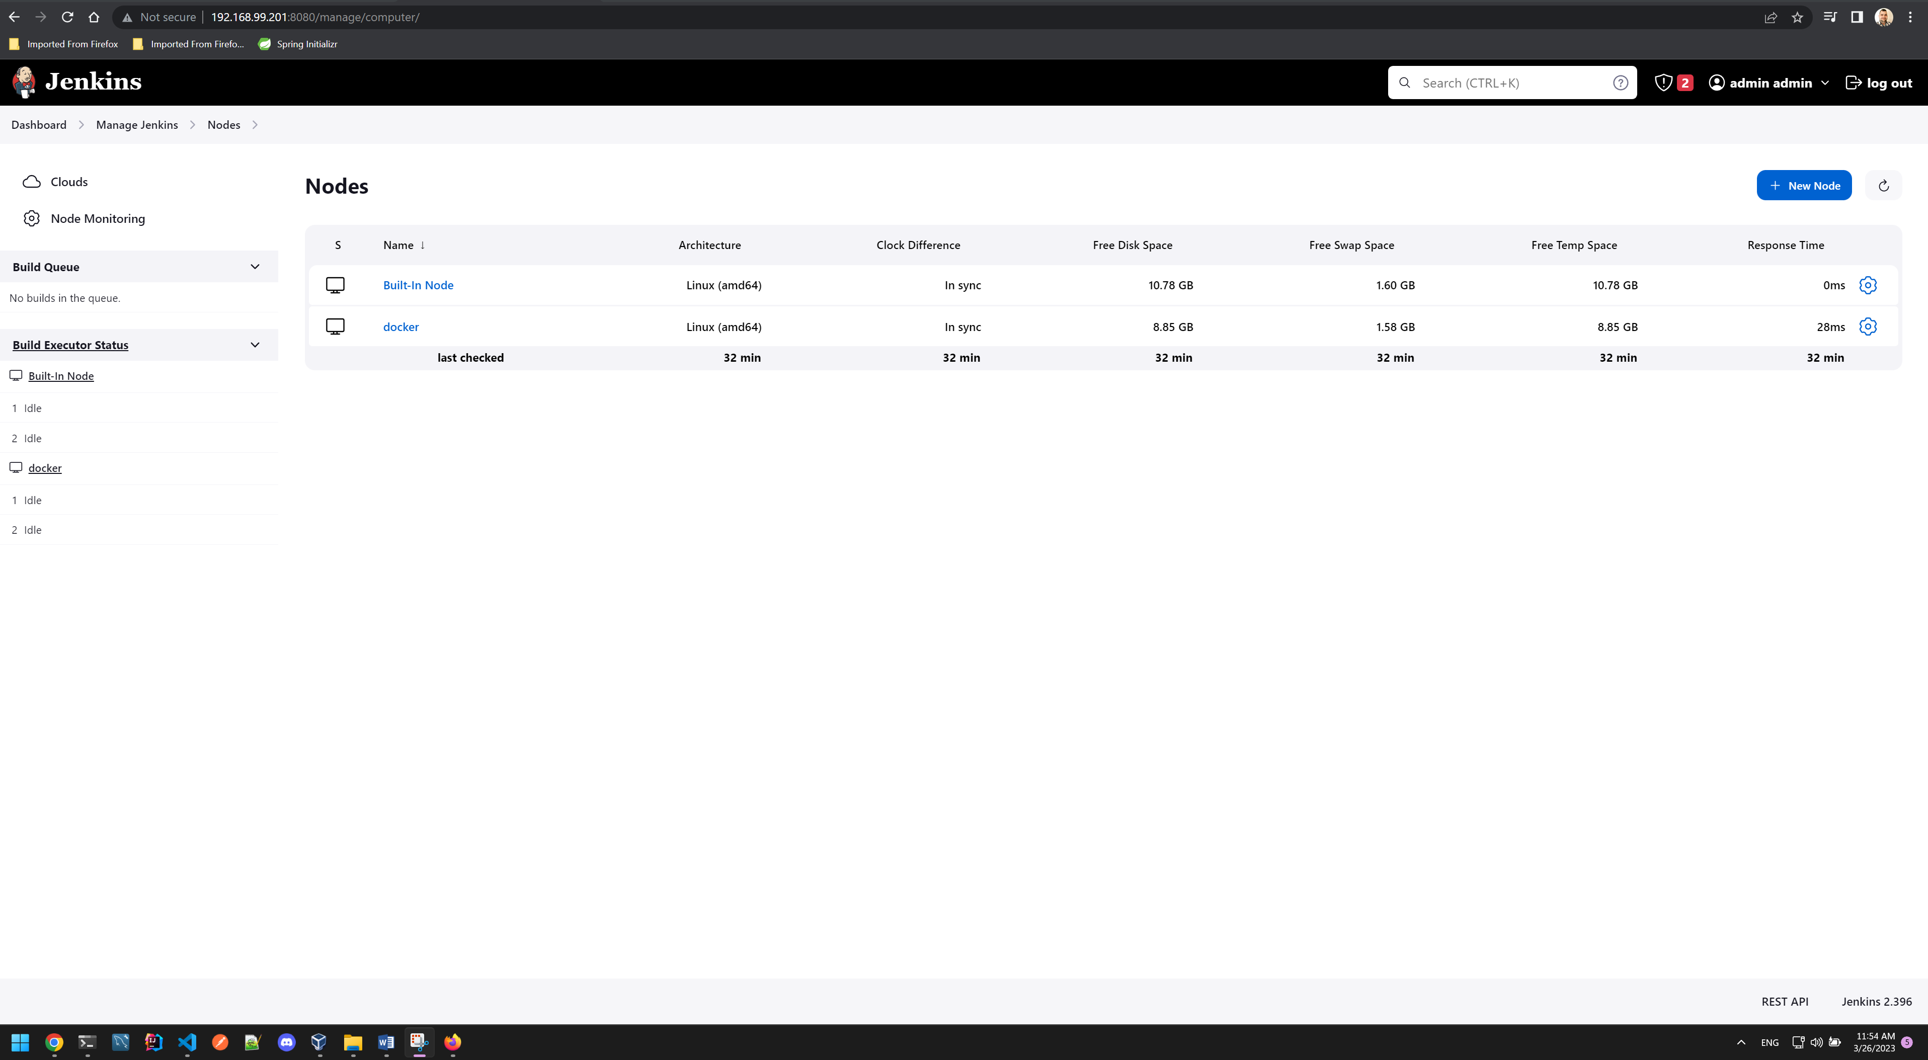

Created folder Exam with pipeline exam:

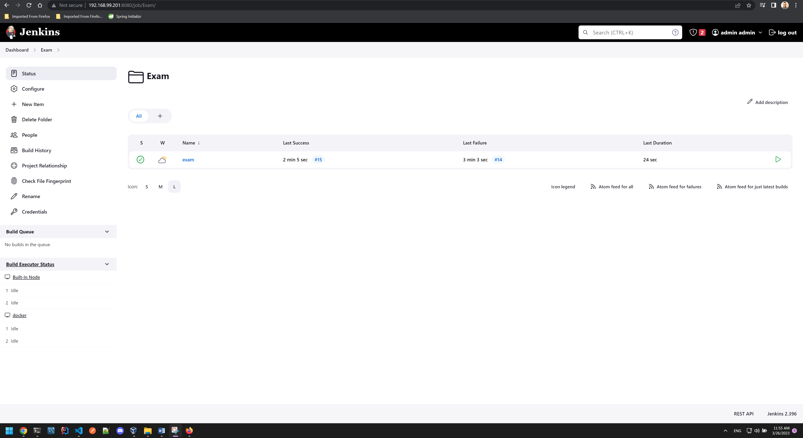

Pipeline script is attached to the assignment archive (file name ‘PipelineScript’).

Successful job execution (prior to webhook trigger):  
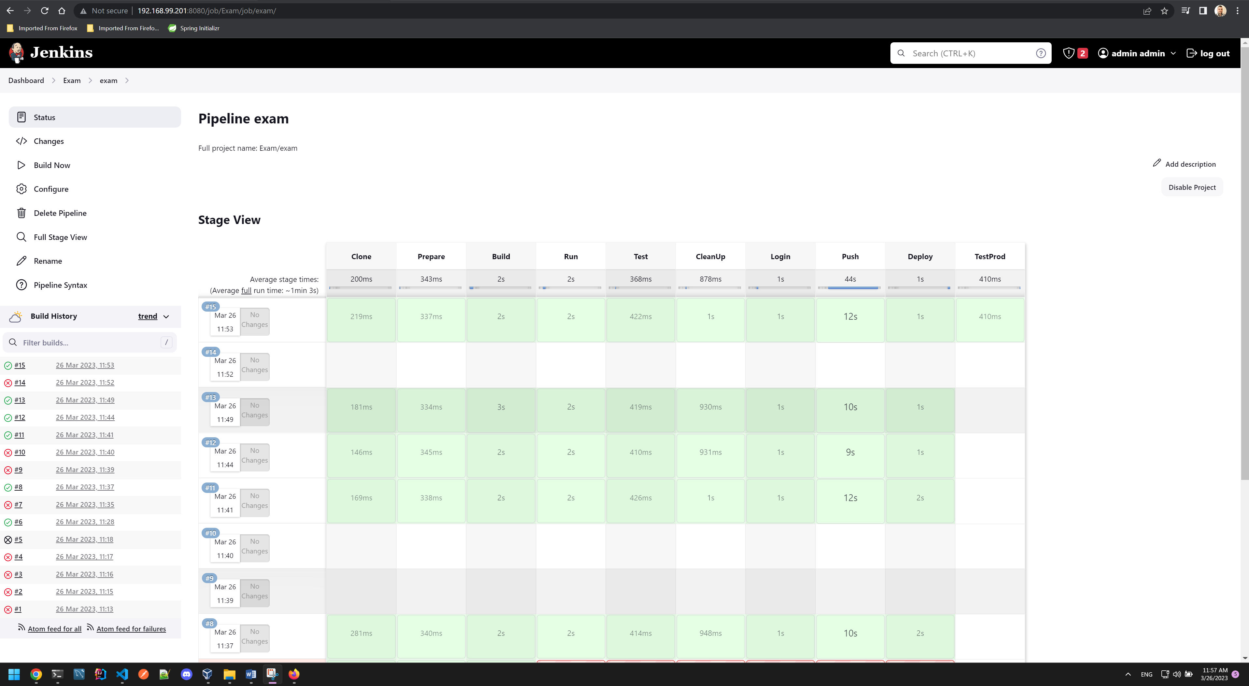

Started working on the webhook trigger:  
Jenkins job:  
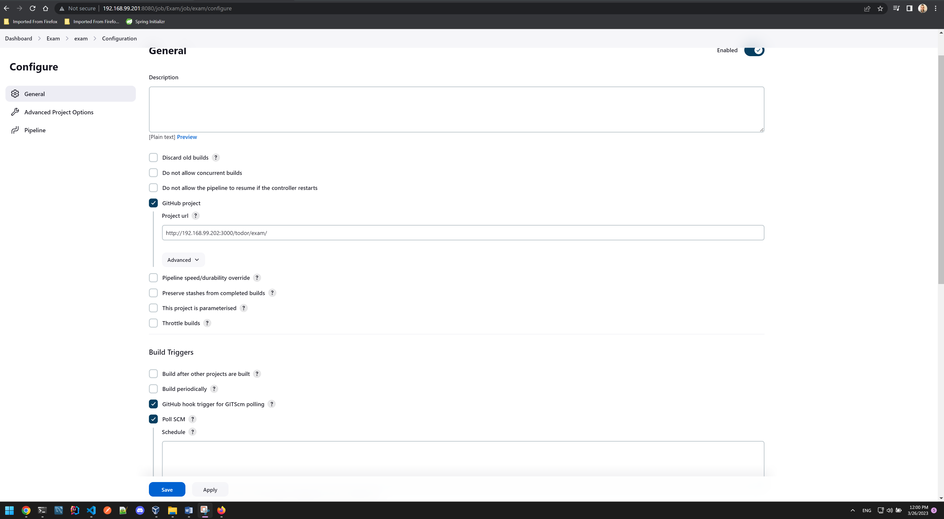

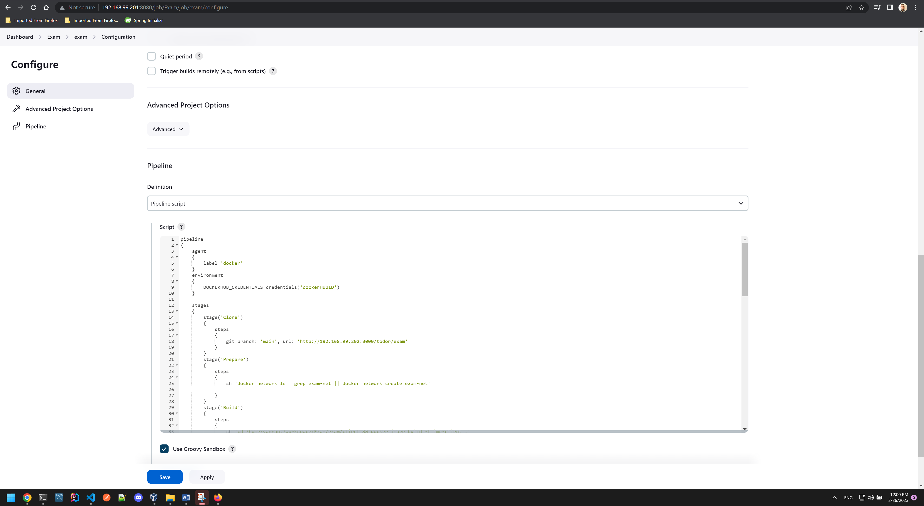

In Gitea – containers.do1.exam

Go to settings – Webhooks – add Gitea Webhook

set up target URL and test webhook delivery

http://192.168.99.201:8080/gitea-webhook/post

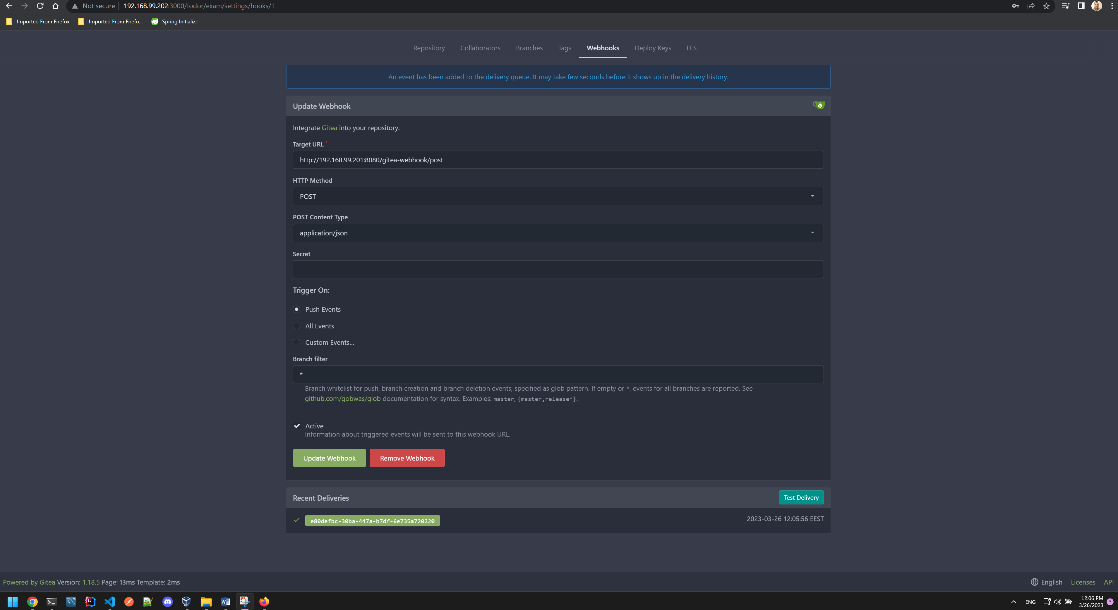

Made changes to the repo and we see in the polling log successful hook call and build

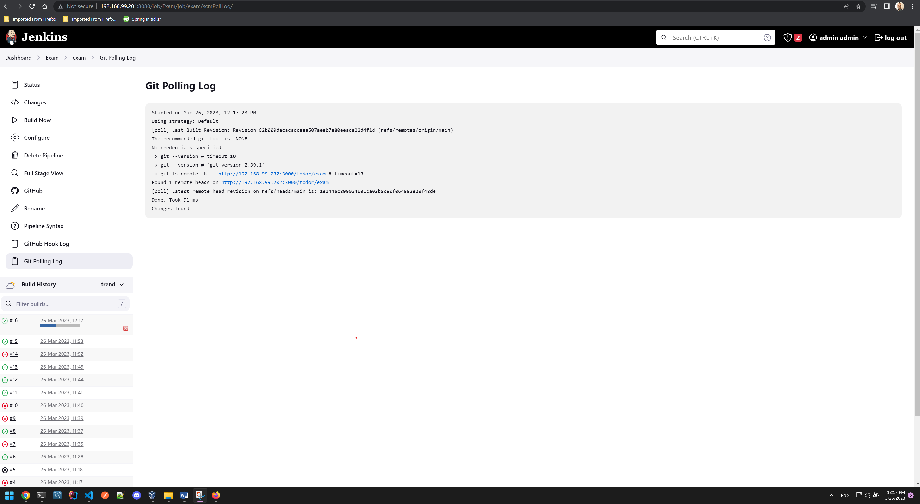

Make change to ***client/code/app.dat*** *file 2023.03.26.12:20:15*

Successful build via webhook trigger

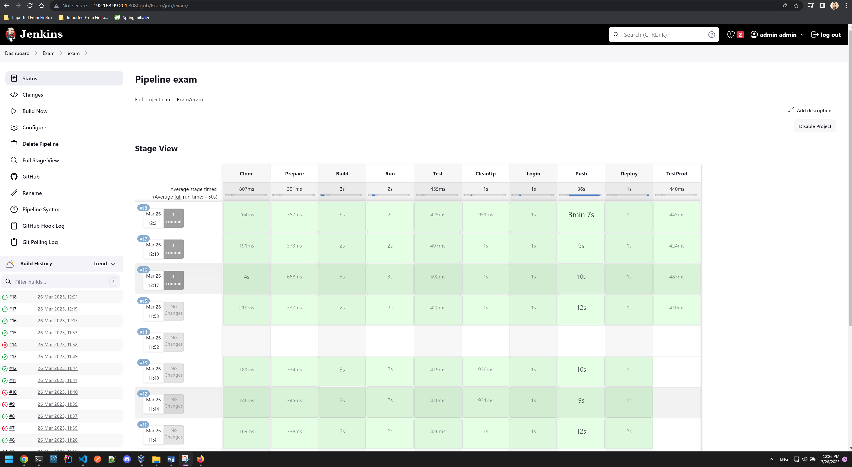

Production application front-end running on 192.168.99.202:80

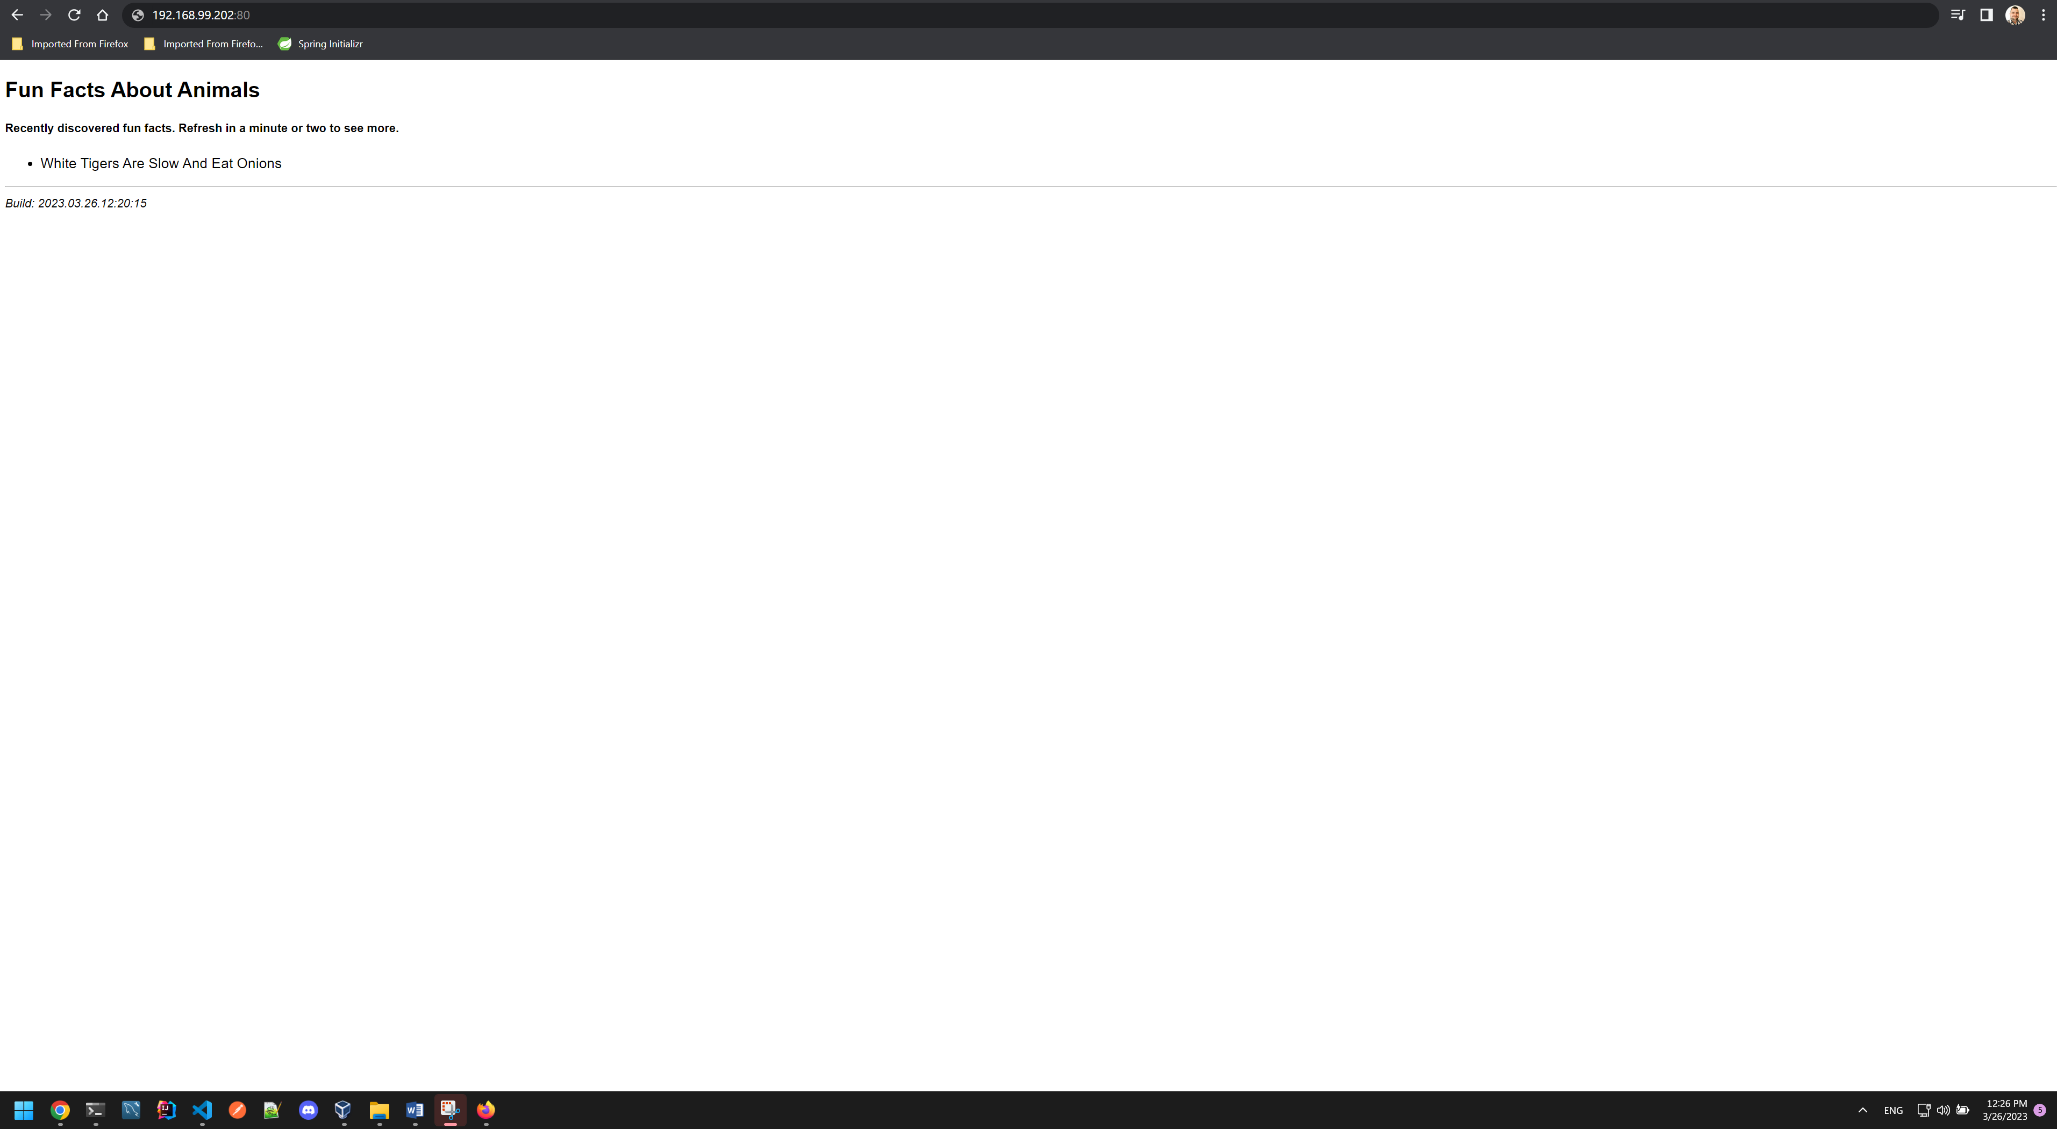

On monitoring.do1.exam

We can see that all node exporters are providing metrics on the given targets:

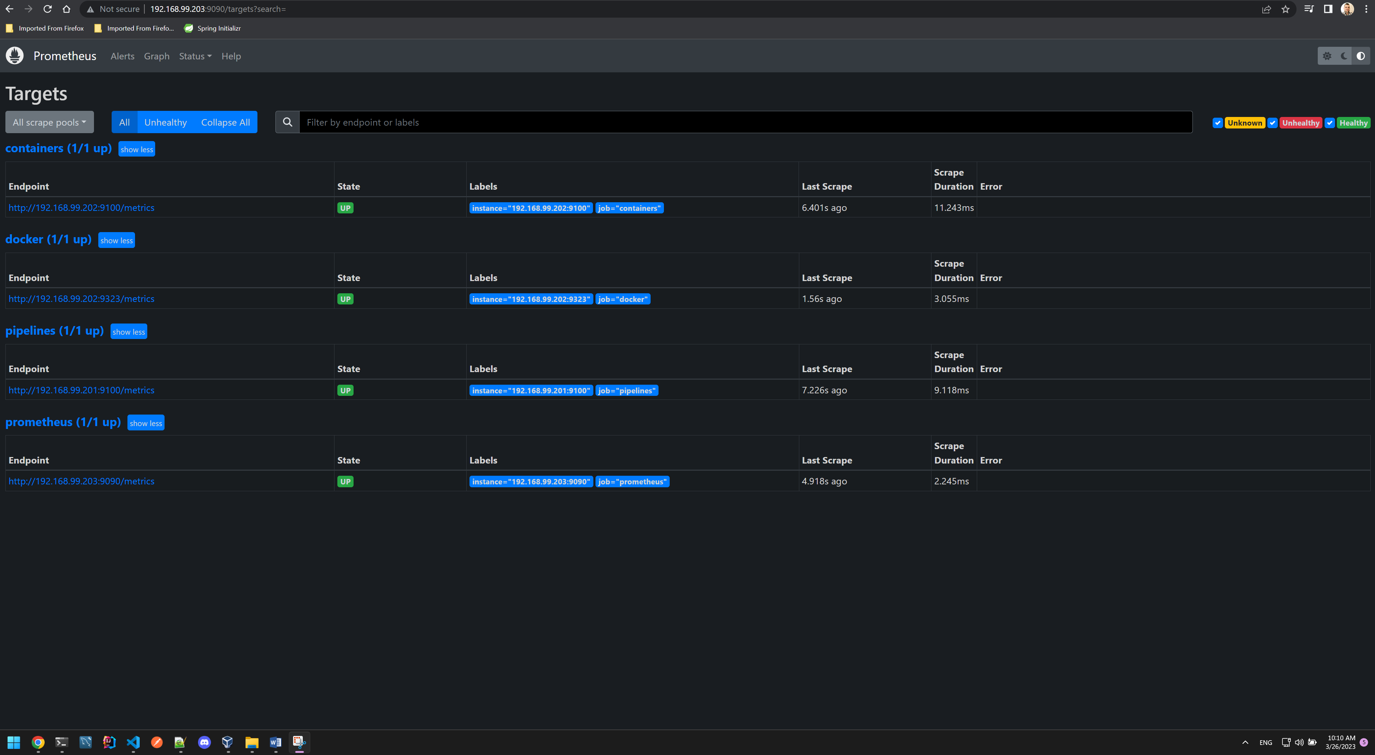

Grafana is up and with configured data source

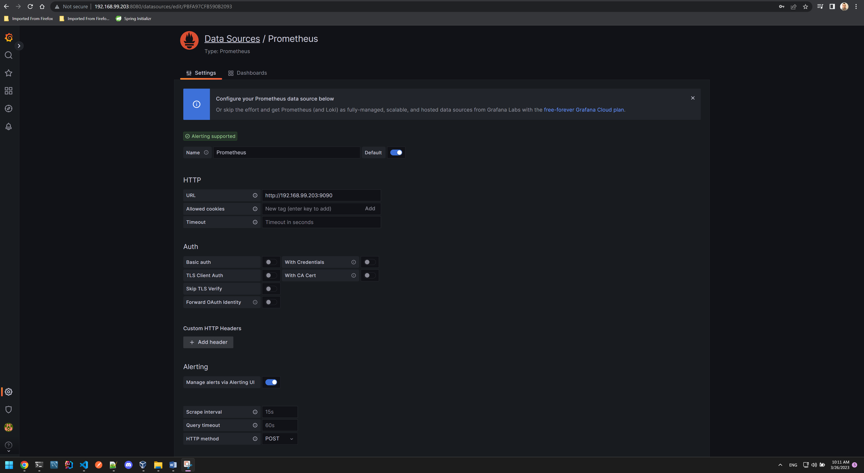

Create a dashboard and configure panel - CPU seconds on both nodes

Used code query - sum by(instance) (node_cpu_seconds_total)

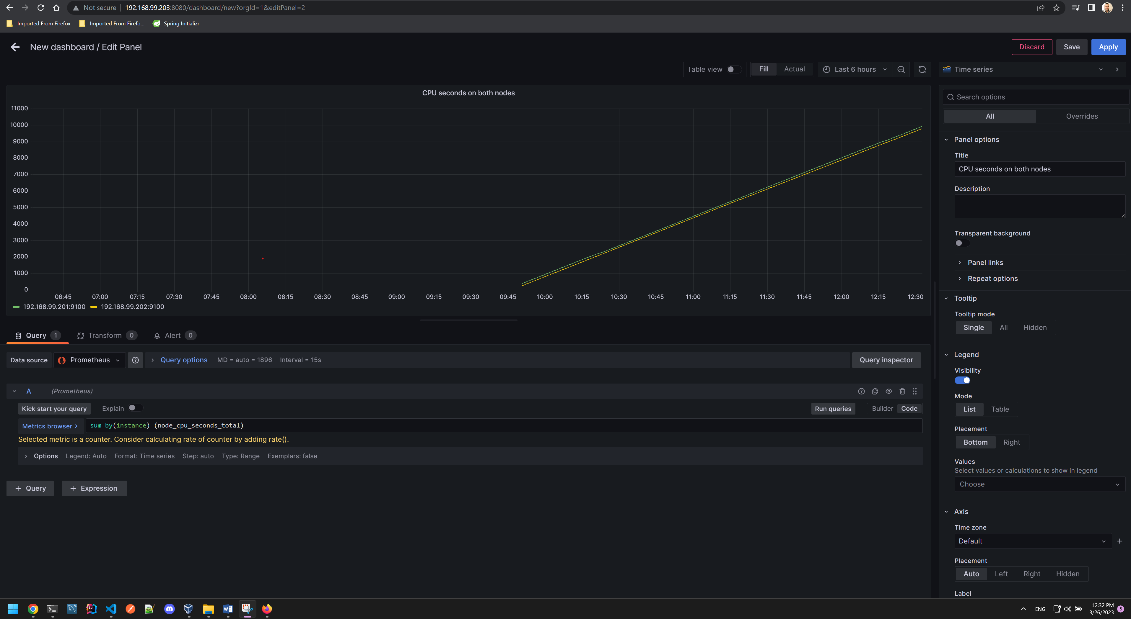

Create a second panel - Memory Available Bytes

Used query - sum by(instance) (node_memory_MemAvailable_bytes)

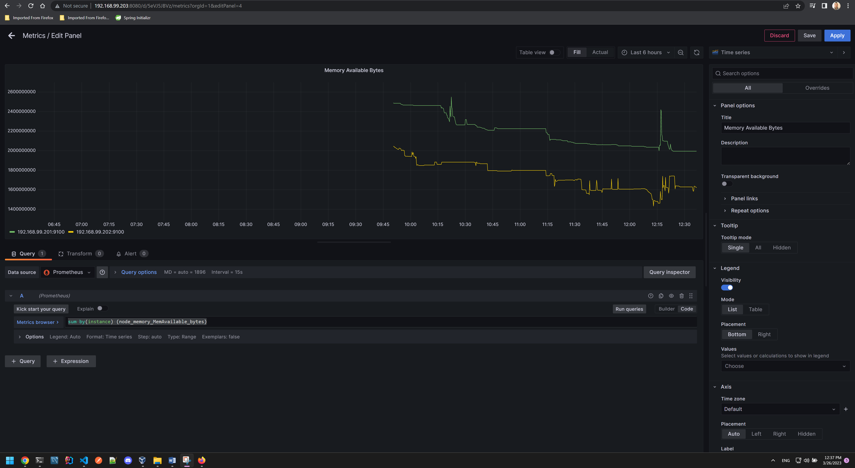

Created third panel – Container states

Used parameter - engine_daemon_container_states_containers

Visualization changed to Stat

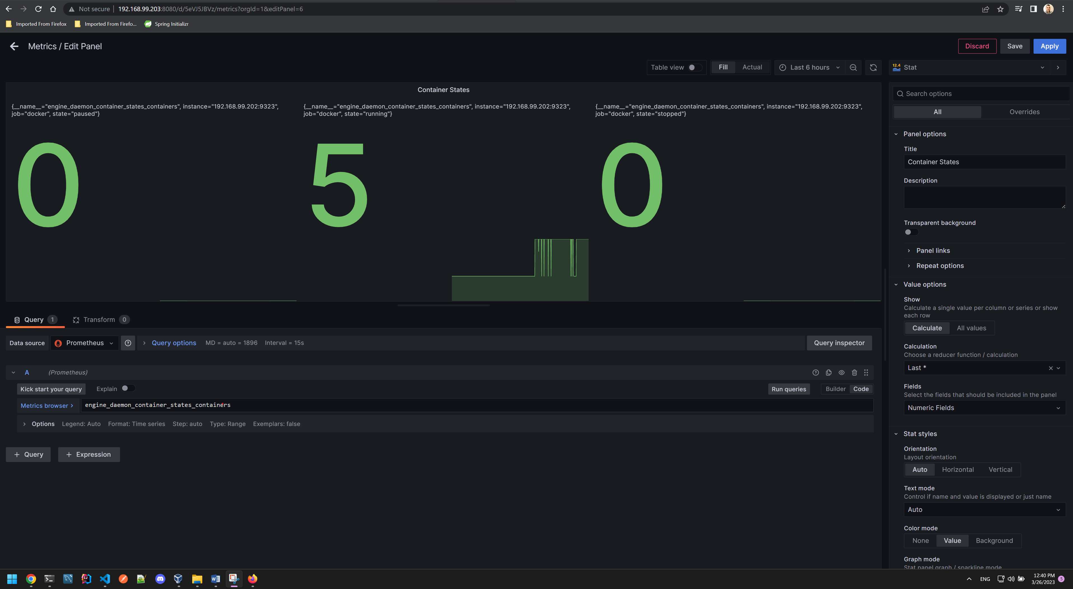

We confirm that the data is correct:



Dashboard – Metrics with all three panels:

